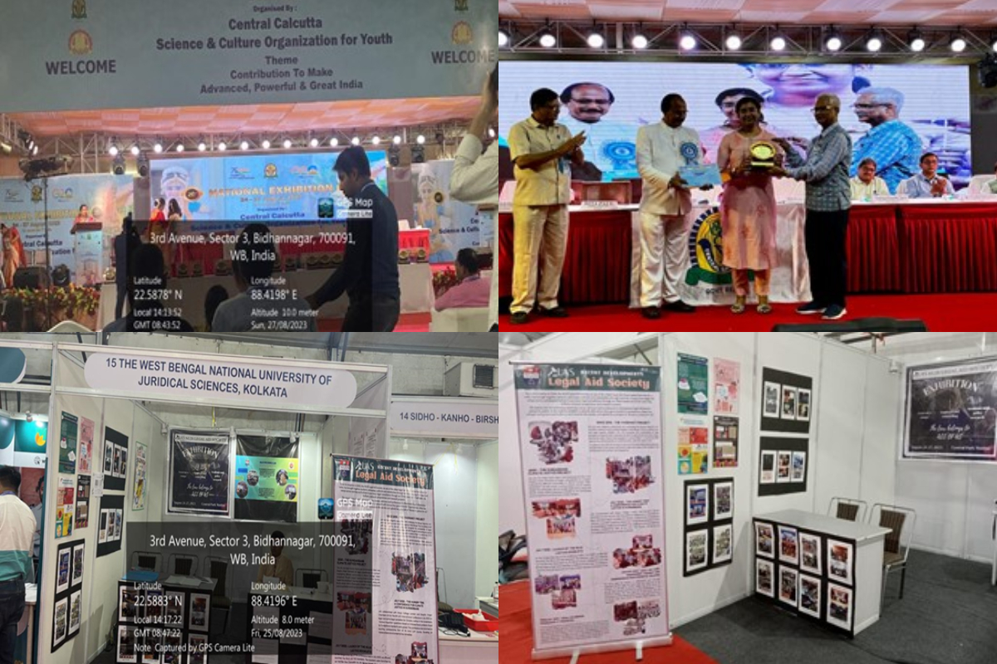

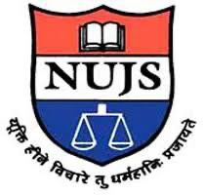

**The West Bengal National University of Judicial Sciences**

**26TH NATIONAL EXHIBITION – ‘CONTRIBUTION TO MAKE ADVANCED, POWERFUL & GREAT INDIA’**

**August 24th to 27th, 2023**

The 26th National Exhibition, titled ‘Contribution to Make Advanced, Powerful & Great India,’ was held from August 24th to 27th, 2023, at Central Park Maidan in Salt Lake City, Kolkata. This event was organized by the Central Calcutta Science & Cultural Organisation for Youth and the society attended it with the primary purpose of creating awareness and increasing the outreach and presence of the Legal Aid Society (LAS). The LAS’s mission is to make a meaningful and concrete contribution to the cause of social justice, and this event aimed to further this noble cause.

The event’s agenda centered around providing basic information regarding court proceedings and legislations to individuals not affiliated with the legal field. The LAS aimed to explain legal principles in a simple and accessible manner. A register was maintained where attendees could share their feelings and thoughts about the LAS’s work. Additionally, the LAS team offered insights into the nature of their work and how individuals could approach them for assistance.

One of the challenges faced during the event was the commitment required to be present for seven hours each day. However, the entire society wholeheartedly embraced this commitment in their dedication to the LAS’s mission. The event concluded with a speech delivered by Anoushka Chakraborty, a fifth-year member of the Legal Aid Society. She eloquently summarized the event’s activities and achievements, including the dissemination of legal knowledge and the positive interaction with a diverse audience.

To recognize the LAS’s efforts and commitment, they were felicitated during the concluding ceremony. The prestigious award was accepted on behalf of the Legal Aid Society by their esteemed Faculty Coordinator, Ms. Sonam Basu.

The Legal Aid Society expressed their gratitude for the opportunity to participate in this event. They extended their heartfelt thanks to their Faculty Advisor, Prof. Dr. Sanjit Kumar Chakrabarti, and their respected Vice-Chancellor, Prof. Dr. Nirmal Kanti Chakraborty. The LAS team expressed their hope to continue making similar meaningful contributions to society in the future.

In conclusion, the 26th National Exhibition served as a platform for the Legal Aid Society to promote social justice, disseminate legal knowledge, and interact with a diverse range of individuals. It was a testament to their dedication and commitment to making a positive impact on society.