**REPORT OF THE 43RD ALL INDIA CRIMINOLOGY CONFERENCE**

The WBNUJS successfully organized the 43rd All India Criminology Conference in collaboration Indian Society of Criminology India on “Reimagining Criminology and Criminal Justice in the Context of Changing Paradigms in Science and Technology” from 17th to 19th December, 2022 at Ambedkar Bhawan, WBNUJS campus. The presence of over Four Thousand dignitaries from across the globe, an impressive lineup of scholars from across the country, the support of sponsors, an array of carefully selected, well-researched and well-presented papers on the subject, all came together to help the Team of the NUJS Family (Faculties/ Teaching Assistants/Research Fellows/ Research Associates and our Beloved Students) to admirably conclude this huge endeavor. The conference included 20 parallel sessions, 4 plenary sessions, one discussion session, besides the Inaugural and Valedictory sessions. This Conference has, without a shade of doubt, made the academic pillar of the criminal justice administration fraternity richer with the additional literature in the form of scholarly works on the subject. The three-day event offered opportunities to the participating audiences to interact with judges, academicians, experts, Prosecutors, investigating agencies scholars and activists from all over the country from Kashmir to Kanyakumari and from seven sisters to Gujarat who deliberated upon and covered topics around the issues of Criminology and Criminal Justice in the Context of Changing Paradigms in Science and Technology”.

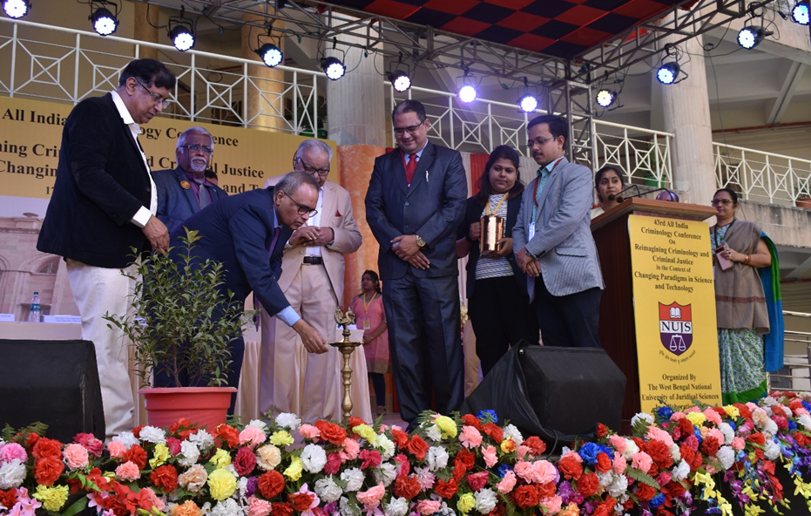

The 21st century has seen rapid scientific and technological developments, that have applied in almost every sphere of life. In the modern era, crime and criminology are no longer considered to be solitary sectors, but rather, it is recognized that they need to be studied in the context of various other streams. These interdisciplinary areas include political science, sociology, psychology, anthropology, economics, and etc. Such an interdisciplinary approach towards criminology has, in fact, been one of the most important steps in recent times towards crime prevention. Thus, it is an important discourse to consider how the current scientific and technological advancements will impact the field of criminology, and how the known theories and paradigms will change as a result of that. This is an important development in ensuring that the modern innovations can be utilized for crime reduction and prevention.

The Conference owes its success to the able guidance of Prof. (Dr.) Nirmal Kanti Chakrabarti, Prof. (Dr.) Balraj Chouhan, Prof. (Dr.) Arvind Tiwari, Prof. (Dr.) P Madhava Soma Sundaram, Dr. Syed Umarhathab, Prof. (Dr.) Kavita Singh, Dr. Sarfaraz Ahmed Khan and the hard work put in by the entire NUJS Family, especially the Organizing team. The Hon’ble Justice Joymalya Bagchi, Judge, Calcutta High Court inaugurated the Conference and delivered a lecture in the presence of distinguished professors such as Prof. (Dr.) MZ Khan, Founding Member of the Indian Criminology Society, Former Professor of Sociology, Jamia Milia Islamia University, New Delhi, Prof. (Dr.) Nirmal Kanti Chakrabarti, Prof. (Dr.) P Madhava Soma Sundaram, Dr. Syed Umarhathab, Prof. (Dr.) Kavita Singh and Dr. Sarfaraz Ahmed Khan.

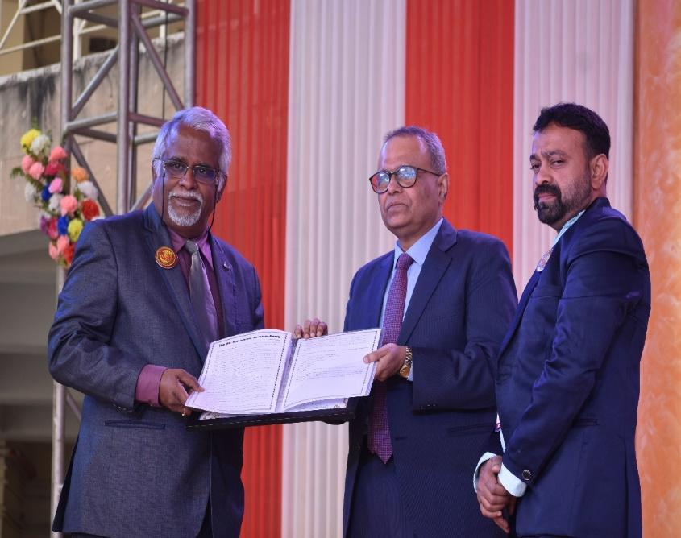

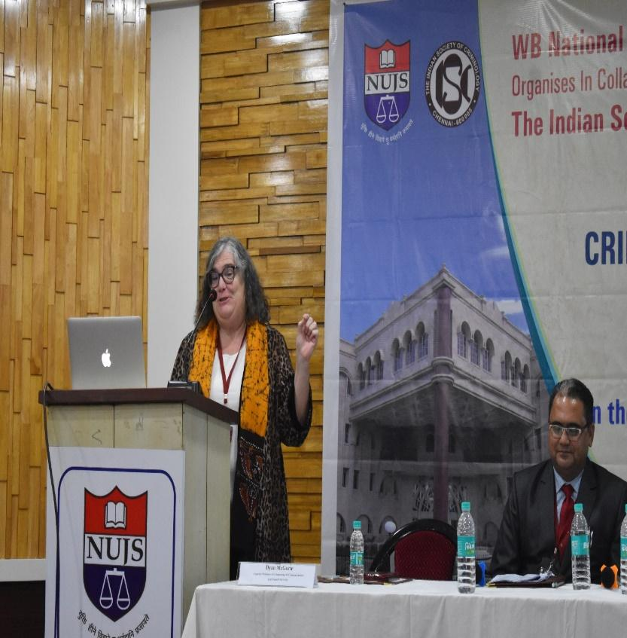

The Conference was blessed with Research Papers on multiple areas such as Gender issues, AI, Cyber Criminology, Green Criminology, Consumerism, Drugs and substances, Trafficking, etc., all from the perspective of science and technology. The multifarious aspects of knowledge led to deep understanding on various Criminological issues within a three-day period. The grandeur and knowledge that the Conference showcased is one of a kind.

The Valedictory session began with felicitation of guests, followed by Welcome address by Dr. Syed Umarhathab, Secretary, ISC.

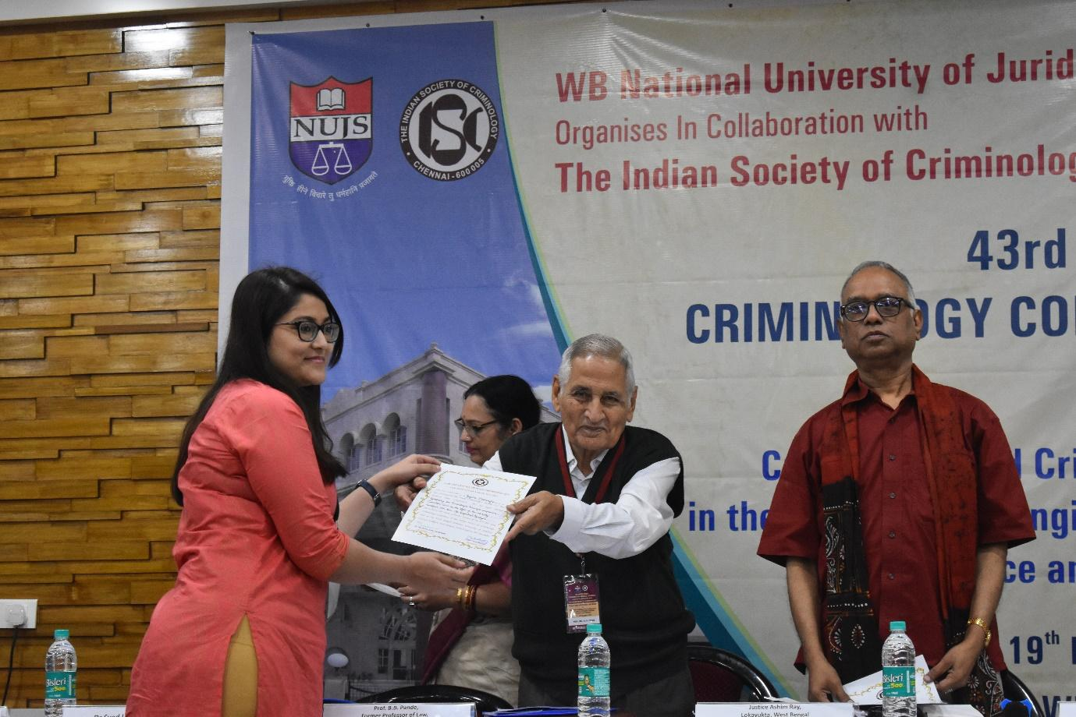

It was followed by the Valedictory address by Prof. B.B. Pande Former Professor of Law, Delhi University and Former President, ISC, wherein he discussed the recent trends of criminal law, its benefits and problems. Thereafter, there was a special Address by Chief Guest, Justice Ashim Ray Lokayukta, West Bengal Former Judge Calcutta High Court. The final address of the valedictory session was by Dr. Sarfaraz Ahmed Khan, Associate Professor and Organizing Secretary, 43rd Indian Society of Criminology WBNUJS, who gave the Vote of Thanks to all the Members of the Indian Society of Criminology, Delegates, Chairpersons, Co-Chairpersons, Moderators, Rapporteurs, Organizing Committee members and the Vice Chancellor, NUJS. The Valedictory Ceremony ended with National Anthem. The number of participants were 500.

