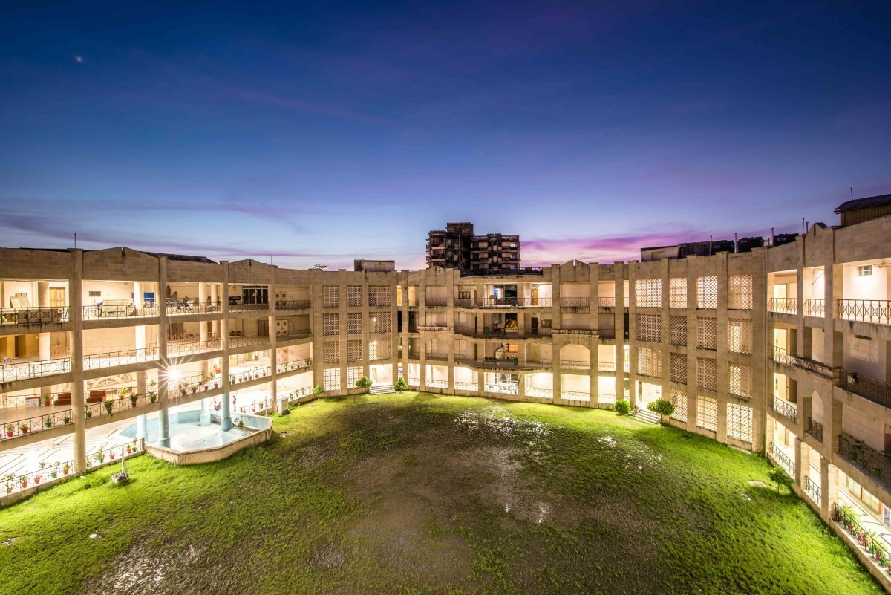

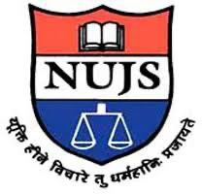

**Report on**

**E-Workshop on Intellectual Property Issues in the 21st Century to celebrate World IP Day On 26th April 2020**

**Organised by: DPIIT IPR Chair, WBNUJS**

**Facilitate By: The IPThink Tank**

**Preface**

The World Intellectual Property (IP) Day is celebrated every year on the 26th of April. This year’s theme was ‘SMEs & IP: Shits & Taking your ideas to market’. It is said that every business starts with an idea i.e. the millions of SMEs that operate across the globe every day started with just an idea that is translated into a product inserted into the market, which in turn contributes to the development of the economy.

For ideas to play a vital role in ensuring a boost to the economy, it is important to note that they need to be nurtured and enriched with ingenuity; the know-how and flair of an idea become an IP asset that can drive the development of businesses, lead to economic recovery and human progression.

At a time when we are all facing a world crisis, there is a need for economic recovery. World IP Day 2020 shines a light on the critical role of SMEs in boosting the economy and how using IP rights can build competitive and resilient businesses.

**Themes and Speakers**

1. Innovation for Green Future: Mr. Subhatosh Majumdar, Founder, S. Majumdar and Co.

2. Inadequacy of IP laws to incorporate growth of Artificial Intelligence: Mr. Utsab Banerjee, Manager, Cognizant Technology Solutions

3. Copyright and the Music Industry: Mr. Ayan Roy Chowdhury, VP, Saregama India Ltd.

4. Disparagement in the 21st Century: Pressing Concern: Mr. Dinesh Jotwani, Co-managing Partner, at Jotwani Associates

5. Future of IP Commercialization Post COVID-19 Pandemic: Mr.Sumantra Mukherjee, Director, KPMG

**Moderators of the Event**

1. Dr. Pinaki Ghosh, DPIIT, IP Chair Professor, WBNUJS

2. Dr. Jayanta Ghosh, Research Fellow, Centre for Regulatory Studies Governance and Public Policy at WBNUJS, Kolkata

The aim of DPIIT IPR Chair is to focus on different aspects of intellectual property rights and it organized the Online Workshop on World IP Day to discuss intellectual property issues in the 21st Century to celebrate World IP Day.

The inauguration speech was given by Dr. Pinaki Ghosh, DPIIT IPR Chair, WBNUJS, and welcomed all the speakers. Dr. Pinaka Ghosh highlighted the different aspects of intellectual property rights issues in the 21st Century during the inaugural.

Mr. Utsab Banerjee, Manager, Cognizant Technology Solutions gave speech on the inadequacy of intellectual property laws to incorporate the growth of Artificial Intelligence.

Mr. Ayan Roy Chowdhury, VP, Saregama India Ltd, discussed the creative industries and different types of creativity.

Mr. Dinesh Jotwani, Co-managing Partner, at Jotwani Associates discussed different parts of Disparagement and related concepts.

Mr. Subhatosh Majumdar, Founder, S. Majumdar & Co., discussed the definition of Green Technology, causes of environmental Pollution causes, future prospects of solar energy, and the Indian Patents on Solar Energy Devices. He also told how the world is protecting green energy by fast-tracking green patent applications.

Mr. Sumantra Mukherjee, Director, KPMG, discussed the various ways of commercialization, and the impact of COVID-19 in business sectors and talked about different aspects of an organization and how they can utilize them to increase their business during this pandemic..

Vote of Thanks by Dr. Pinaki Ghosh, DPIIT IPR Chair, WBNUJS.