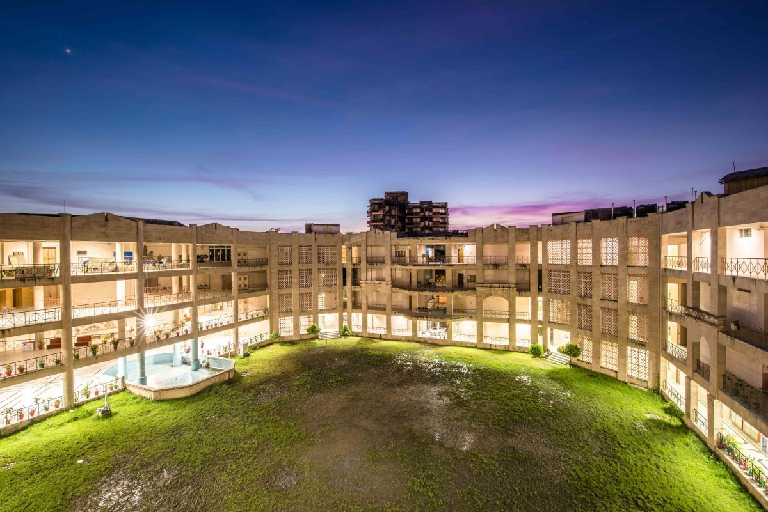

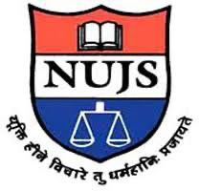

**Training Workshop & Field Survey**

**On**

**"Geographical Indication" From 10.12.2021 to 12.12.2021 at Purulia District**

The training workshop was held on 10th December 2021 with the Govt. Officers and stakeholders are at the conference hall of the District Magistrate Office.

**Objectives**

1. To discuss the benefits of GI

2. To discuss the necessity of GI

3. To discuss Legal and technical parts of Gl

4. Boost up of the local economy and employment generation.

5. Prospective Gl identification at Purulia District.

**Presented Member from G1 Drive Committee**

1. Dr. Pinaki Ghosh, DPIIT IPR Chair, WBNUJS

2. Dr. Jayanta Ghosh, Research Fellow, CRSGPP, WBNUJS

3. Mr. Partha Sarathi Chakraborty, Asst. Secretary, National Gl Drive Mission.

The training workshop was arranged by Sri Prabir Kumar Roy. General Manager. District Industries Centre. Purulia. The meeting was graced by Sri Supriya Das, WBCS (Exe). Additional District Magistrate (LR). Purulia. He started the meeting and introduced the Gl Drive Mission officers to the Govt. Officials and

Prof. (Dr.) Pinaki Ghosh, IP-Chair Professor, WBNUJS started off the inaugural session with welcome & opening remarks. He welcomed the Govt. officials and the stakeholders and discussed meaning of Geographical indication, laws relating to it, post registration challenges.

Dr. Jayanta Ghosh, gave a PowerPoint presentation on the topic of experiences of producers with the protection of geographical indications and explained that the application for the registration must contain Gl application form, a statement of case, the geographical map of the country/region or locality, the particulars regarding the appearance of the Gl, an affidavit as to how the applicant claim to represent the interest of the concerned persons/ producers authority or organizations.

Partha Chakraborty, Asst. Secretary of GI Drive Mission, discussed with the Officials how Gls will be helpful to develop the state as well as said district.

In an interaction session with stakeholders on probable GI, the stakeholders wanted all round participation and assistance to NUJS for achieving the said Gl for the district. They also added two names Palm Tree & Shallac for a probable GI Product and urged quick support and initiation of registration to meet the goal and deadline.

A vote of thanks was given by Dr. Pinaki Ghosh.