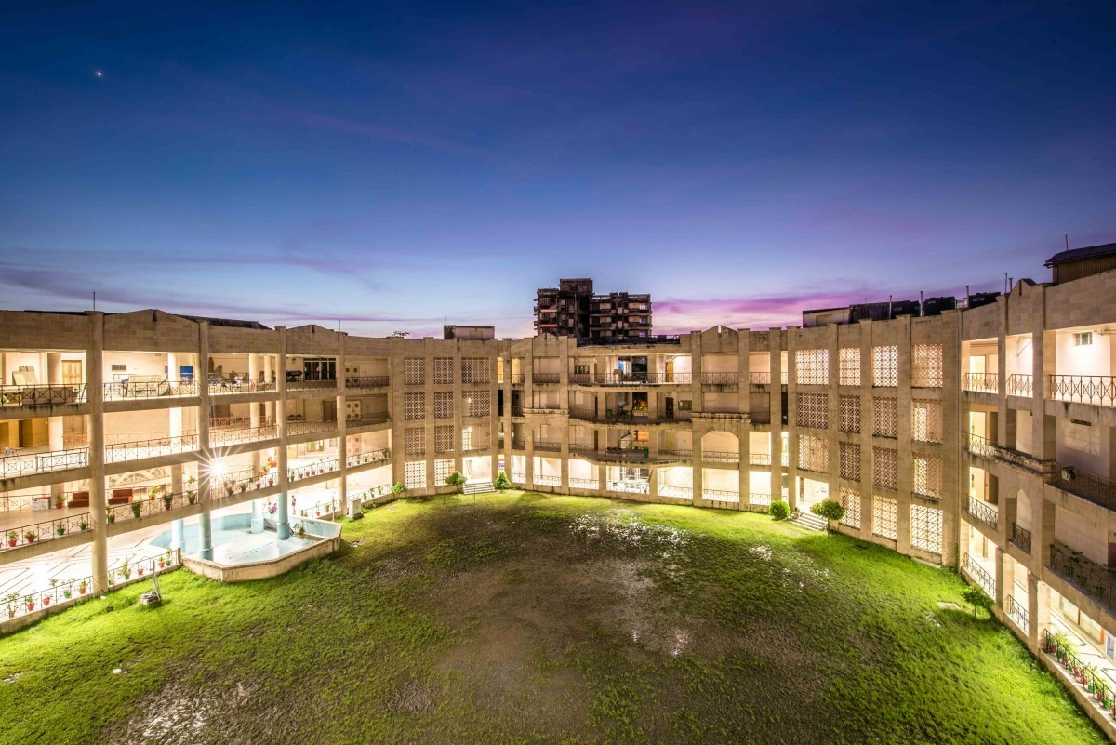

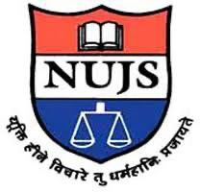

**"National Geographical Indication Drive Mission" Facilitated by DPIIT IPR Chair, WBNUJS**

**Report On Training Workshop**

**On "Geographical Indication"**

The training workshop was held on 12th November 2021 with the Govt. Officers from the Horticulture, Sericulture, and Agriculture department, as well as GMDCI, PDDRDC at the conference Hall of District Magistrate Office from 11 AM to 3.30 PM.

**Objectives**

1. To discuss the benefits of GI

2. To discuss the necessity of Gl

3. To discuss the Legal and technical parts of GI

4. Boost up the local economy and employment generation.

**Presented Member from GI Drive Committee**

1. Dr. Pinaki Ghosh, DPIIT IPR Chair, WBNUJS

2. Dr. Jayanta Ghosh, Research Fellow, CRSGPP, WBNUJS

3. Mr. Partha Sarathi Chakraborty, Asst. Secretary, National GI Drive Mission.

The training workshop organized by DM Jhargram and assisted by DPPRDO Jhargram Ms Sharmistha Bhattacharjee (WBCS)

Meeting was inaugurated by Dr. Pinaki Ghosh, DPIIT IPR Chair, WBNUJS. The training workshop witnessed the presence of Mr. Anirban Sanyal, superintendent Of Excise Jhargram, Dr. Khurshid Alam, DHO, Jhargram, Sk. Gaosal Alam, Dy. PD (A/C) DRDC, Jhargram, Mr. Goutam Mandal, DM & DC, Jhargram, Mr. Tarapada Sur, Manager, DIC, and the stakeholders of probable GI products of Jhargram District were also benefited by the workshop.

Dr. Pinaki Ghask, DPIIT IPR Chair said "Geographical Indications is a name/sign used on goods that have a specific geographical origin and possess qualities, reputation or characteristics that are essentially attributable to that place of origin.

Dr. Jayanta Ghosh, Research Fellow, CRSGPP, WBNUJS gave a powerpoint presentation on the topic experiences of producers with the protection of geographical indications.

Partha Chakraborty, Asst. Secretary of Gl Drive Mission, discussed with the officials how Gls will be helpful to develop the state as well as said district.

In an elaborate discussion on the possibility of making PDDRC Jhargam, M Sharmistha Bhattacharjee (WBCS) wanted all-around participation and assistance from NUJS to achieve the said G1 for the district.

In the thanksgiving speech, Dr. Pinaki Ghosh, asked for further cooperation and assistance from district officials for the identification and processing of probable Gl of Jhargram.