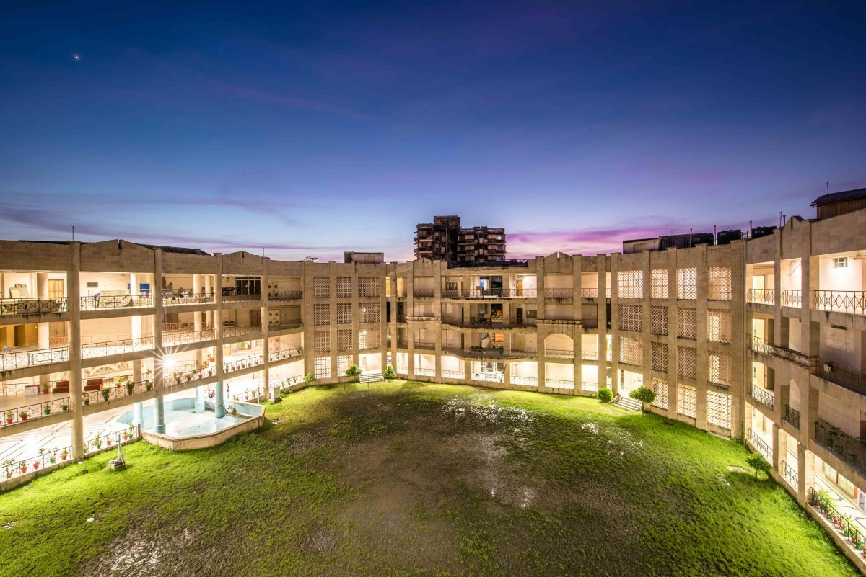

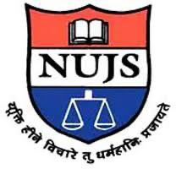

**Report on Training Workshop on Advanced Intellectual Property Rights**

**On 11th and 12th March 2021**

**Organized byDPIIT Chair, WBNUJS**

**At Manipur Police Training College, Pangei, Manipur**

Department for Promotion of Industry and Internal Trade (DPIIT) Chair, WBNUJS Kolkata organised a two days workshop on Advanced Intellectual Property Rights with special reference to counterfeit and piracy products. The workshop included several sessions that include, inter ala, Copyright Act, Patent, Trademark, Biodiversity etc.

Dr. Sovik Deb Barnman discussed the relationship between health and science and development.

Dr. Supratim Riv, BO PSS BFWPM shared his concern on how he can relate IPR with his department.

Finally, the workshop was conducted by appreciating the officials of the Government of Tripura.