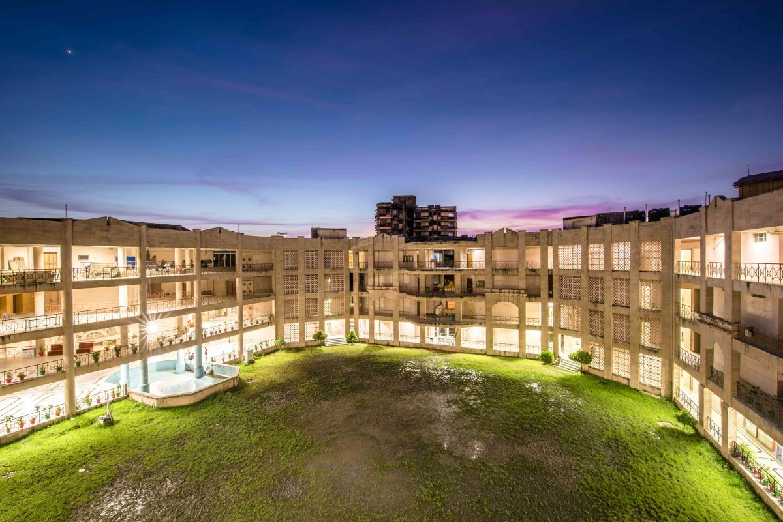



**Report on National Webinar on Trend of Fashion Industry and Design Complication in The Global Intellectual Property Scenario**

**On 21 December 2021 at 3.00 PM-5.00 PM (Online)**

The Webinar was started by Rima Ghosh, Research Assistant. The Honourable Vice-Chancellor Prof. (Dr.) NK Chakraborty delivered the welcome speech and inaugurated the webinar to address the topic of fashion law and design. Dr. Pinaki Ghosh, Chair Prof. DPIIT IPR Chair delivered the keynote speech and welcomed the resource person.

Ms. Ananya Bhattacharya, Director Banglanatak.dot com, spoke on geographical indications and traditional knowledge. The discussion agenda was on the commercialization of ICH Gil and Cultural Industries, using IP as a marketing tool.

The West Ben

The second speaker, Prof Sanjib Kumar Das, Associate Professor NIFT Kolkata discussed Pre and post-COVID-19 pandemic on the Fashion Industry.

The third speaker was Mr Debabarata Sengupta, Founder and Owner Art Wing. He spoke on the practical modalities for Leather and Batik design.

The fourth speaker was Prof. Shantanu Jena, associate Prof of Visva Bharti University. He spoke on Sustainable Design through Craft Development.

The webinar ended with a vote of thanks by Dr Jayanta Ghosh, Research Fellow CRSGPP.