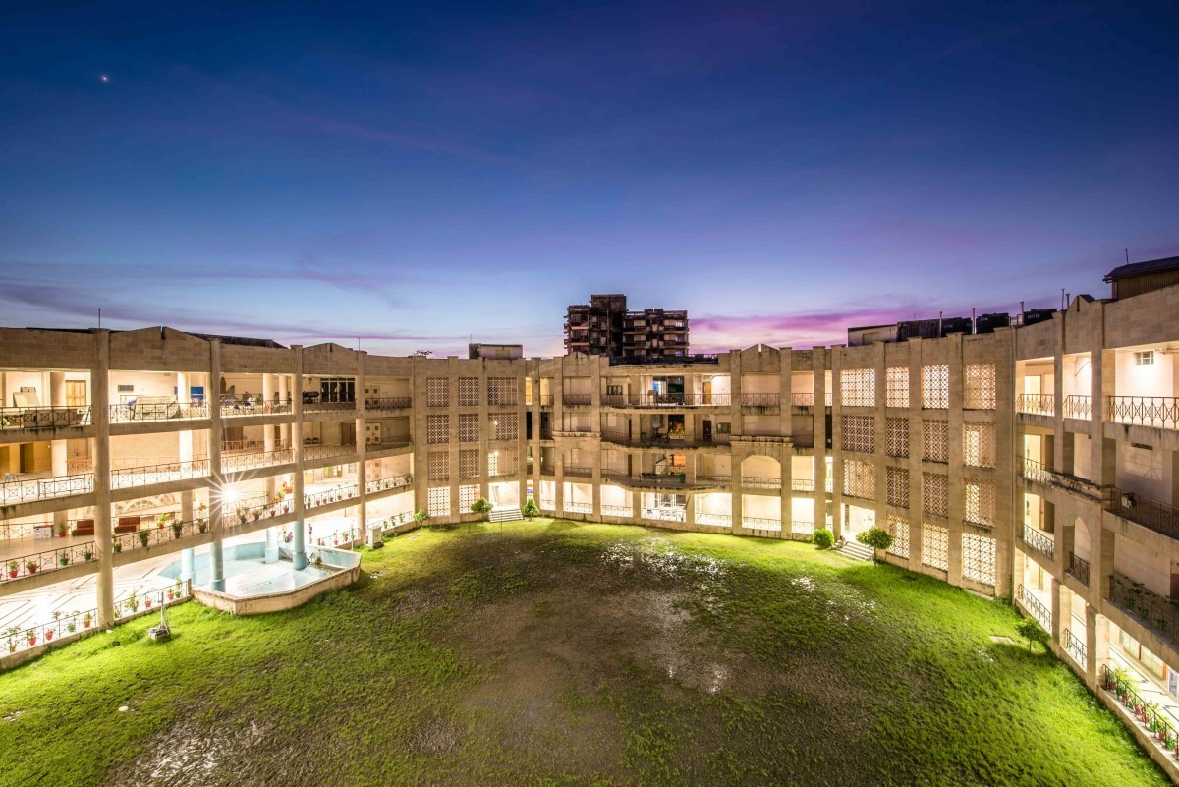

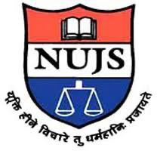

**Report on**

**Workshop on Protection of Brands & IP: The Fight against Duplicates**

**13th December 2019**

**Venue: WBNUJS**

The IP Chair Prof, WBNUJS in collaboration with NASCAP & CRSGPP. WBNUJS conducted an one-day workshop as a step towards fighting against counterfeiting and piracy. The inauguration was graced by Dr. Guriqbal Singh Jaiya, Director-Advisor, WIPO, Hon'ble Justice Dr Ashimkr Roy, Lokyukta of West Bengal, Moloy Ghatak, Minister in charge of the Judicial and Law Department, Prof. N.K Chakrabarti, Vice-chancellor of WBNUJS. Mr. Debasis Ghosh, Department of West Bengal, Ministry of Housing, and Mr. Sandip Kumar Roy Choudhury, Law Secretary, Govt. of West Bengal. During the inaugural ceremony, the Hon'ble speakers highlighted the importance of IP Brands and Duplication and counterfeiting. The theme is contemporary in this age and should be emphasized in every institution. They specifically stressed the contemporary relevance of the workshop's theme.

In the first technical session, Dr. Mahua Hom Chaudhary, Patent Information Centre, West Bengal State Council of Science and Technology, highlighted the completed work and future projected work by the Patent Information Centre of West Bengal. Dr Shambhu Prasad Chakrabarty, Head & Research Fellow at Centre for Regulatory Studies Governance and Public Policy at WBNUJS, Kolkata mentioned the Traditional Knowledge and "Sui Generis" legislation for India. Mr. S.K Mitra, former Deputy Controller of Patent and Trademark Office, Kolkata observed that enforcement mechanism for IP infringement is very weak in India Dr. Jayanta Ghosh, Research Fellow at Center for Regulatory Studies, Governance and Public Policy, The WBNUJS categorically mentioned the statistics of counterfeiting and piracy of the brands, the places where the counterfeiting products are available and shared specific solution to curb the duplication. In his view, counterfeiting and duplication may be restrained while controlling the excessive cost of the branded products.

In the second technical session, a discussion was put forward about the Indian Film Industry Mr. Supran Sen, Secretary General, Film Federation of India and Chairperson of Media & Entertainment, NASCAP was the moderator of the session, and in this panel, others are Mr. Arijit Dutta, Managing Director, Priyalintertainment Pvt. Ltd, mentioned the old version film

system and the present system. The theatre system will never die, irrespective of technological advancement. He further emphasized certain people of performance like theatre. The next panelist, Mr. Himanshu Dhanaka, Director, Eksay Video Pvt. Ltd. movie production house mentioned the Indian cinema industry's business structure and how it is changing from quality to quantity. Mrs. Ratnottama Sengupta, Senior Film Critic & Curator, Film Festival, discussed copyright violations from pre-independence to post-independence.

In the third technical session, Mr. N. Mahon, Founder & CEO, LEO Corporate Consulting, UAE discussed brand protection in the electronic industry and awareness of the use of branded products. The next panelist Mr. Raj Kumar Panicker, GM, Legrand & lead IEE MA,elabotated on how counterfest products adversely affects human life.

In the last Panel Mr Kamanashis Sen, IPS, Additional SP, Rural, Hooghly, shares overview of intellectual property law, and his experience with counterfeiting products in his jurisdiction Then Mr. Peeyush Pandey, IPS, ADG, SCRB, WB, mentioned different enforcement system to counter the duplicate products.

A vote of thanks was given by Dr. Pinaki Ghosh, MHRD IP Chair.