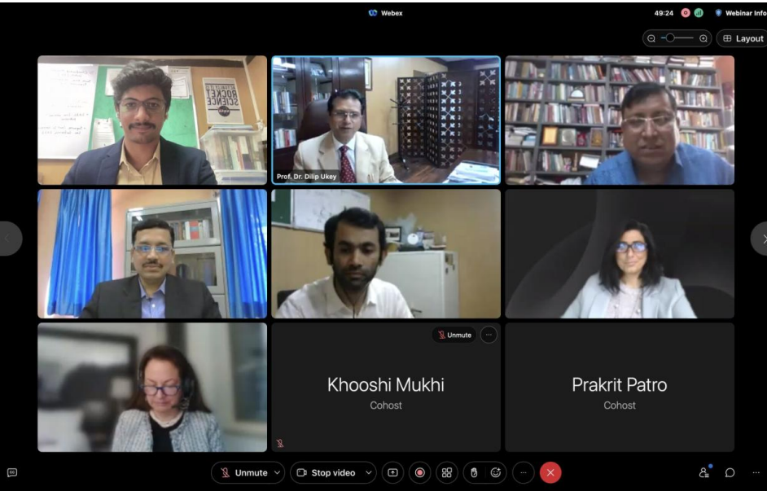

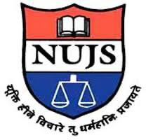**The West Bengal National University of Judicial Sciences**

**Report of the International Symposium on Air and Space Law**

Theme for 2023: Dispute Settlement in Air and Space Law

On 6 May 2023 the Centre of Aviation and Space Laws, National University of Juridical Sciences, Kolkata and the Centre for Research in Air and Space Law, MNLU Mumbai hosted the Annual International Symposium on Air and Space Law 2023 on the theme ‘Dispute Settlement in Air and Space Law’. This was another event where both centres engaged in policy deliberation by analysing and gauging the legal developments in the field of aviation, space, and allied areas. The sessions involved discourse by stalwart scholars, academicians, practitioners and researchers. The symposium began with a welcome address delivered by Mr. Adithya A. Variath, Coordinator of the CRASL, MNLU Mumbai, which was followed by the patrons’ address from Prof. (Dr.) Dilip Ukey, Vice-Chancellor of MNLU, Mumbai and Prof. (Dr.) N.K. Chakrabarti, Vice Chancellor of WBNUJS, Kolkata. Subsequently, a detailed yet succinct inaugural address was delivered by Prof. (Dr.) Sandeepa Bhat, the director of CASL, WBNUJS on ‘ICJ’s Approach to Aviation Dispute Resolution’. Stress was laid upon the ICJ’s failure to read into the treaty provision as well as to give due weightage to non-adversarial dispute resolution mechanisms, which are key to better international relations and peace. This was followed by a Keynote Address on the topic of ‘Litigating Due Regard’ by Michelle L.D. Hanlon, the Co-Director of the Air and Space Law Program, University of Mississippi School of Law’s Center for Air and Space Law. The attendees could also witness a Special Address on challenges that States face while implementing international space law in the domestic level by Dr. Maria A. Pozza, Director & Lawyer – Gravity Lawyers and DirectorOtago Foreign Policy School, New Zealand. Mr. Amana Khare, Research Assistant at MNLU Mumbai concluded the inaugural session by delivering a warm vote of thanks to the organizers, the participants and resource persons. Technical Session I was started off by Amna Al Owais, Chief Registrar of the DIFC Courts, Dubai, by speaking on the future of air and space law dispute settlement. Being a practitioner, her focus has been on the development of new mechanisms to ensure quick and efficient resolution of disputes. This was followed by Laura Zielinski, Attorney at Holland & Knight Mexico SC, presenting a perspective on investment arbitration in the space sector. Andrea Trimarchi, a Lecturer of Aviation Law and International Law at University of Cologne, was the next speaker who enlightened the attendees on the role of domestic courts in resolving air and space law disputes. Ishita Das, an Assistant Professor of Law at NALSAR Hyderabad, followed the discussion on the topic ‘The Claims Commission under the Liability Convention: Troubleshooting the Dispute Resolution Forum’. Aaditya Vikram Sharma and Lipi Garg from the Vivekananda Institute of Professional Studies, Delhi concluded this session by outlining their perspectives on space dispute resolution mechanisms. Dr. Divya Tyagi, the head of V.S. Mani Centre for Air and Space Law, GNLU, Gandhinagar started the second technical session by bringing his vast array of experience on corporate insolvencies afflicting aviation industry to the attendees. This was followed by Saniya Khanna and Sudhir Verma from VIT-AP, VSL, Vijayawada and Symbiosis Law School Noida on the issue of settlement of disputes in space tourism. The concluding presentation of this session was on the Antrix-Devas case by Madhur Samriti Sharma, NALSAR University of Law, Hyderabad. The presentation unfolded the serious concerns of the existing dispute resolution mechanisms in dealing with high-end space disputes. The opening presentation of the third technical session was given by Adithya Variath, Assistant Professor and Coordinator, CRASL, on ‘Shaping the Future of Outer Space Dispute Settlement: (Re)Reading the PCA’s Optional Rules for Arbitration of Disputes Relating to Outer Space Activities’. The second presenter of this session, Ms. Subhashini and Mr. Bhagavatula Naga Sai Sriram from SASTRA University augmented the perspectives on the role of technology in resolving air and space law disputes. After this, it was Mohd. Sufiyan Khan and Dr. Mirza Juned Beg from TERI, School of Advanced Studies, New Delhi, who deliberated upon the impact of air and space law disputes on international relations and peace. The concluding presentation of this last technical session was given by Michael Thomas Thevaril and George Thomas Thevaril from St Joseph’s College of Law Bengaluru on evaluating the most effective means for peaceful settlement of space disputes. Each presentation at this symposium was unique, and each participant gained an in-depth understanding of many aspects of international aviation and space dispute resolution, particularly from a legal standpoint. Every session included a dedicated fifteen-minute question and answer period, which was found to be highly engaging and fruitful. The satisfaction of participants is reflected in the highly positive feedback that we have received from them. The symposium was a huge success with its lasting impact on the participants. The outcome of the symposium is certain to make an essential contribution to the academics and regulatory framework across countries. The event was attended by over 200 participants