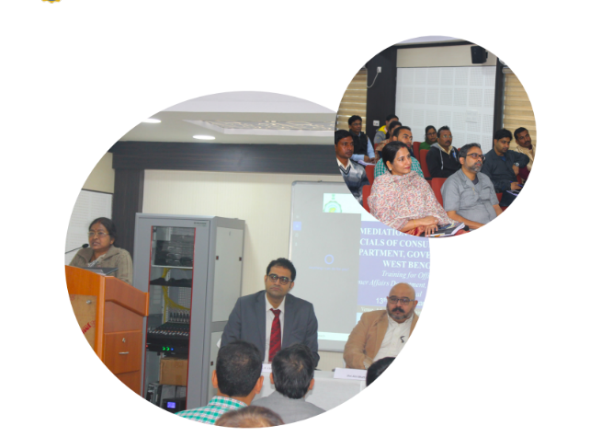

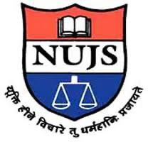

**The West Bengal National University of Judicial Sciences**

**Mediation Consumer Grievances Training Program**

06.01.2020-17.01.2020

The Department of Consumer Affairs, Government of West Bengal, in collaboration with CRSGPP, conducted a two-week training programme on Mediation in Consumer Grievances. The training was in consonance with the provisions and rules of the amended Consumer Protection Act, 2019. The training structure was created by Sama, an organization founded by NUJS graduates in 2015 and recognized by the Ministry of Law and Justice, Government of India in the top 12 Alternative Dispute Resolution (ADR) Institutions of India. The training content and structure was in consonance with the 40 hours Supreme Court Mediation Training Manual. The training was conducted at Administrative Training Institute, in two batches, from 6th January 2020 to 17th January 2020.